 

INFRASTRUCTURE APPLICATION REQUIREMENTS -  
DIM-Infosphere

**(Data Integratie Magazijn – Infosphere)**

Version: 1.0

Date: *30-10-2023*

Based on Template: UWV REQ – TEMPLATE 2.0docx

## Table of Contents

Table of Contents 2

Document purpose: 3

Relation to other documents 4

Content of the document 4

Document change history 4

1 Application Overview 5

1.1 Introduction 5

1.2 Scope of the desired change 5

1.3 Application use cases 5

1.4 Out of scope 5

2 Architecture 6

2.1 Conceptual 6

2.2 Context diagram 7

3 Functional Requirements 38

4 Non-Functional Requirements 39

4.1 Security & Compliance classifications 39

4.2 System and Software requirements 39

4.3 Performance requirements 45

4.4 Security requirements 45

4.5 Backup and Recovery 45

4.6 Disaster Recovery 47

Appendix: Legenda Context Diagram 48

## Document purpose:

What is the Requirement document and why?

The requirement document is a Word document owned and managed by UWV.

The template of the requirement document can be found at this link: [Joined Collaboration Platform](https://dxcportalgbr.sharepoint.com/sites/UWVJCP/Delivery/Infrastructure/Forms/AllItems.aspx?RootFolder=%2Fsites%2FUWVJCP%2FDelivery%2FInfrastructure%2F00%5FInstructies%20en%20Templates%20%2D%20HLD%20en%20Requirements%20management&FolderCTID=0x012000E2656A960112194C951E9D08878546D9&View=%7B325BC795%2D92C8%2D49C8%2D9509%2D5F65CBCD32A3%7D) If you cannot access the link, ask access to [jcp@uwv.nl](mailto:jcp@uwv.nl)

If a business division would like to :

1. implement a new CI (application)
2. modifiy an existing CI (for example an upgrade of a server, a new connection request, a new functionality, a new component, a new server, etc.)

Then the business division (using the template) should fill-in the requirements, which will be reviewed according to the “HLD Fabriek” process.

Special requests – as exceptions – could be handled outside the “HLD Fabriek” process.

Once the requirement document will be filled-in for a new/existing CI, the business division which owns the CI will become also the owner of the requirement document, also for future versions and changes.

Why the requirement document is important ?

1. The requirement document is a collection of wishes and requirements from the business division to the leverancier DXC.

The document contains requirements:

on hosting (hardware, software) level

on security en compliancy level

on network level (connections)

on functionality level (use cases)

on performance level

and it will be used by DXC to:

* Gain a general understanding of the application requirements
* Deliver the Infrastructure Application design (IA HLD): after the validation of the HLD by the UWV Technical Design autority (TDA) a “building permit”or “Bouwvergunning” is issued by the TDA. That is the starting point for projects realization phase. For more info on the TDA please turn to the ICT Services Lead Architect.

1. The requirement document is also important because it has a contractual relevance

Why the requirement document must be written in English ?

Because the Requirement document and the HLD are considered technical documents and DXC is a global company with employees from all over the world, thus English is the official language.

Name of this requirement document

The name of this requirement document = name of the application (CI).

A correct application name must be used, consistent with confipedia (use exact full name, case sensitive). Link to site: [Confipedia](https://samenwerken.sharepoint.uwv.nl/sites/ict/pm/config/basl%20html/index.html)

In case this document describes a cluster of applications, each application must be mentioned here separately

Contact:

If you have questions, feedbacks or remarks regarding this template, please contact ict.ior_applicatiehosting@uwv.nl

## Relation to other documents

The following documents may be relevant as context to this REQ:

* The Software Architecture Document (SAD). If available deliver the SAD as a separate document.
* The Project Start Architecture (PSA) document

Infrastructure Application design produced by DXC for related applications (interfaces)

## Content of the document

UWV has prepared this document in good faith and is based on the information gathered during the requirement determination phase with all parties involved; application vendors, UWV architects, developers and UWV functional management.

## Document change history

Please note:

For brand new applications: UWV needs to deliver to DXC a “major” version 1.0

For existing applications (already implemented in production for example) UWV needs to deliver to DXC a new, updated version of the requirement document.

|  |  |  |  |
| --- | --- | --- | --- |
| Version | Date | Author | Summary of Changes |
| 1.0 | 30-10-2023 | TP de Goede | Requirements document based on HLD v1.2.1 |
| 1.1 | 7-12-2023 | F. Abdul | Creation of REQ document based on v1.0 |
| 1.2 | 11-12-203 | R.Stienstra | Addition of Firewall rules for Oracle Enterprise manager |

# Application Overview

## Introduction

Where in this document “DIM” is mentioned, the “DIM-Infosphere” application is meant.

The DIM deployment consists of a Linux, AIX and Windows Production, Acceptance, Test and Development environment with interfaces to several input sources for the ETL (Extract Transform Load) of business data.

DIM provides both a web-based interface for users located in the UWV KA domain and a Windows based FAT client which will be deployed in the DXC datacenter.

Implementation of DIM will be based on the generic services and building blocks.

DIM Infosphere consists of the following components:

* DIM Service: DIM services servers
* DIM Search: DIM search servers (zookeeper)
* DIM Engine: DIM Engine servers
* DIM Bridge: DIM Bridge servers
* DIM DB: DIM Infosphere database server
* DIM FS: DIM Infosphere NFS server (contains hot and cold data share)
* DIM Deploy: DIM management server used for promotions (deployments)
* DBA-GD RDP: Remote desktop server for DBA Gegevensdiensten

## Scope of the desired change

UWV-TAB (Oracle DBA’s) want to use Oracle Enterprise Manager (OEM) in order to manage the Oracle database landscape. OEM will be installed on the existing aix management server. This server already serves as interconnectivity platform for deployment purposes, this change involves the addition of specific IP ports for communication between AIX management server and the OTAP-AIX database servers, and also https inbound from the DBA-GD RDP server to the management server over a custom https port.

## Application use cases

Application use cases are not defined, not applicable, or unknown to DXC.

## Out of scope

* Functional Application Management is not in scope for DXC
* Technical Application Management is not in scope for DXC
* Database Administration is not in scope for DXC
* Dim Infosphere FATclient installation on UCRA is out of scope for this HLD and must be considered as part of the UCRA design
* All components that belong to the UWV Office Infrastructure such as workstations, web browsers are out of scope
* How InfoSphere licensing method

# Architecture

## Conceptual

UWV selected IBM InfoSphere Information Server as the new target solution for ETL.

IBM® InfoSphere® Information Server provides a unified architecture that works with all types of information integration. Common services, unified parallel processing, and unified metadata are at the core of the server architecture.

The architecture is service-oriented, enabling IBM® InfoSphere® Information Server to work within evolving enterprise service-oriented architectures. A service-oriented architecture also connects the individual suite product modules of IBM® InfoSphere® Information Server.

By eliminating duplication of functions, the architecture efficiently uses hardware resources and reduces the amount of development and administrative effort that are required to deploy an integration solution.

The main concepts are:

1. Unified parallel processing engine
2. Common connectivity (structured/unstructured data sources)
3. Unified metadata (enables shared understanding between business and technical domains)
4. Common services (set of shared services that centralize core tasks across the platform)
5. Unified user interface (common graphical interface and tool framework)

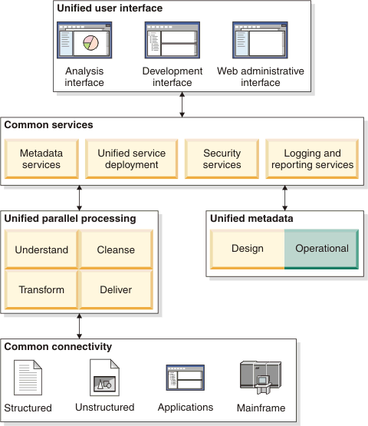

## Context diagram

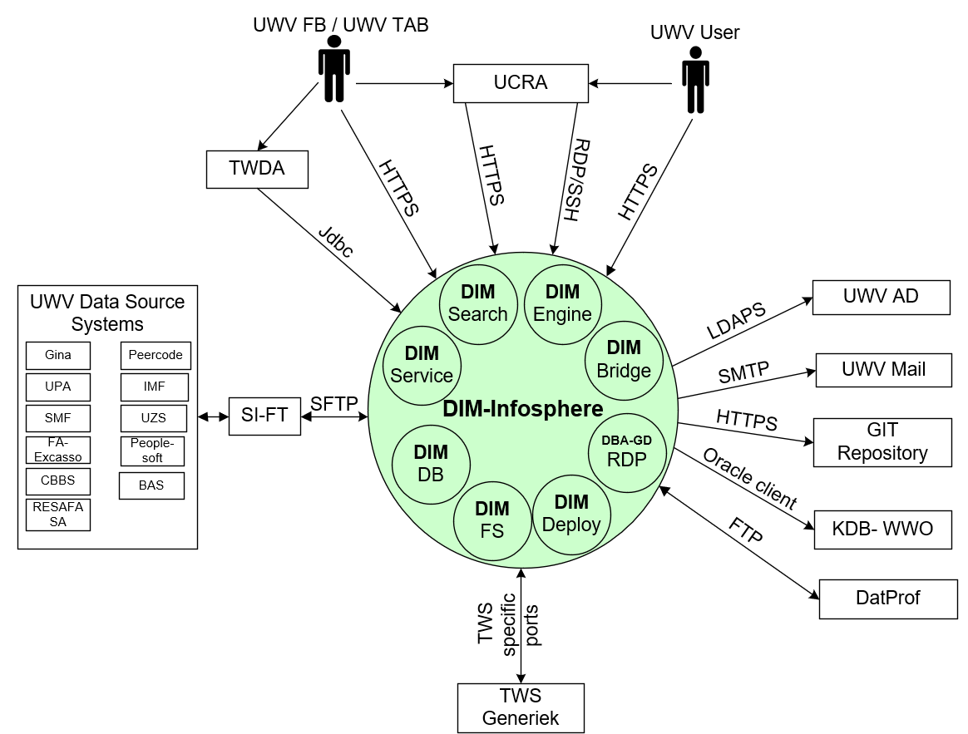

The above diagram shows the Context Diagram and the external entities for the DIM-Infosphere application. Due to the complexicity of the application the application is split in different components. The different components are represented by the small green circles and wil be described in the next chapters in more detail.

### DIM Service

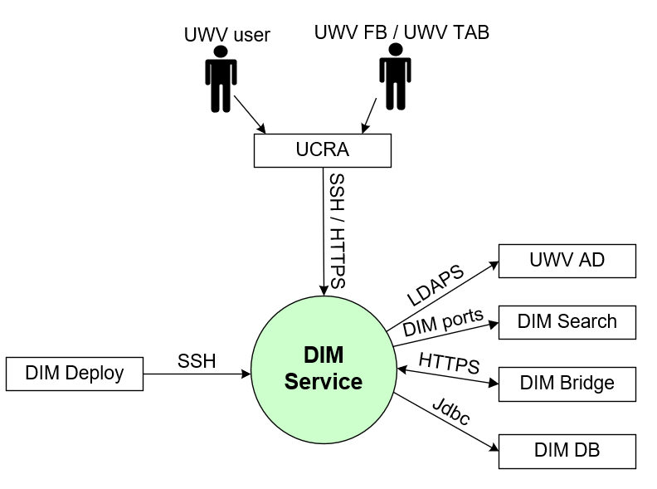

#### External entities

##### UWV Users

|  |  |
| --- | --- |
| **Description** | Developers and Data Engineers as part of UWV Users community |
| **Protocol and Port** | SSH, port 22; HTTPS, port 9443 |
| **DC (Datacenter) connection** | Internal (within DXC datacenter) (mandatory field) |
| **Direction** | Inbound (connection initiated by the entity) (mandatory field) |
| **Direct connection** | No (mandatory field)  Via: UCRA |
| **Security Controls** | Authorisation method or authentication method: RBAC (AD) (mandatory)  Use certificates: Yes (Entrust)  Service account: No |
| **Number of users** | Not specified |
| **Number of transactions** | Not specified |
| **Frequency of transactions** | Daily |
| **Volume of data** | Not significant |

##### UWV FB / UWV TAB

|  |  |
| --- | --- |
| **Description** | A user performing functional and technical Application Management tasks. This is mainly related to the configuration of ETL processes and reports, but also management of the application itself. Web Browser and several IIS clients are used for performing these tasks. |
| **Protocol and Port** | SSH, port 22; HTTPS, port 9443 |
| **DC (Datacenter) connection** | Internal (mandatory field) |
| **Direction** | Inbound (mandatory field) |
| **Direct connection** | No (mandatory field)  Via: UCRA |
| **Security Controls** | Authorisation method or authentication method: RBAC (AD) (mandatory)  Use certificates: Yes (Entrust)  Service account: No |
| **Number of users** | 2-5 |
| **Number of transactions** | Not specified |
| **Frequency of transactions** | Daily |
| **Volume of data** | Not significant |

##### UWV AD

|  |  |
| --- | --- |
| **Description** | Windows Active Directory domain containing resource groups of which UWV domain (KA prod or WPOL) user groups are member, and by which UWV accounts are granted rights. |
| **Protocol and Port** | Kerberos (88), LDAP (389), LDAPS (636), Global Catalog (3268, 3269) |
| **DC (Datacenter) connection** | External (mandatory field) |
| **Direction** | Outbound (mandatory field) |
| **Direct connection** | Yes (mandatory field)  Via: <If No is selected specifiy otherwise mention not applicable> |
| **Security Controls** | Authorisation method or authentication method: RBAC (AD) (mandatory)  Use certificates: No  Service account: Yes |
| **Number of users** | Not specified |
| **Number of transactions** | Not specified |
| **Frequency of transactions** | Not specified |
| **Volume of data** | Not specified |

##### DIM Search

|  |  |
| --- | --- |
| **Description** | Internal Application communication with DIM search |
| **Protocol and Port** | TCP: 2181, 9092 |
| **DC (Datacenter) connection** | Internal (mandatory field) |
| **Direction** | Outbound (mandatory field) |
| **Direct connection** | Yes (mandatory field)  Via: <If No is selected specifiy otherwise mention not applicable> |
| **Security Controls** | Authorisation method or authentication method: None required (mandatory)  Use certificates: No  Service account: No |
| **Number of users** | Not specified |
| **Number of transactions** | Not specified |
| **Frequency of transactions** | Not specified |
| **Volume of data** | Not specified |

##### DIM Bridge

|  |  |
| --- | --- |
| **Description** | Internal Application communication with DIM Bridge |
| **Protocol and Port** | Connection 1: HTTPS, 19433  Connection 2: HTTPS, 9433 |
| **DC (Datacenter) connection** | Connection 1: Internal (mandatory field)  Connection 2: Internal (mandatory field) |
| **Direction** | Connection 1: Outbound (mandatory field)  Connection 2: Inbound (mandatory field) |
| **Direct connection** | Connection 1: Yes (mandatory field)  Connection 2: Yes (mandatory field) |
| **Security Controls** | Authorisation method or authentication method: Select (mandatory)  Use certificates: Yes (Entrust)  Service account: No |
| **Number of users** | Not specified |
| **Number of transactions** | Not specified |
| **Frequency of transactions** | Not specified |
| **Volume of data** | Not specified |

##### DIM DB

|  |  |
| --- | --- |
| **Description** | Database connection to Infosphere DB |
| **Protocol and Port** | Jdbc, 1526 |
| **DC (Datacenter) connection** | Internal (mandatory field) |
| **Direction** | Outbound (mandatory field) |
| **Direct connection** | Yes (mandatory field)  Via: <If No is selected specifiy otherwise mention not applicable> |
| **Security Controls** | Authorisation method or authentication method: Select (mandatory)  Use certificates: No  Service account: No |
| **Number of users** | Not specified |
| **Number of transactions** | Not specified |
| **Frequency of transactions** | Not specified |
| **Volume of data** | Not specified |

##### DIM Deploy

|  |  |
| --- | --- |
| **Description** | Internal Application communication with the DIM Management server |
| **Protocol and Port** | SSH, 22 |
| **DC (Datacenter) connection** | Internal (mandatory field) |
| **Direction** | Inbound (mandatory field) |
| **Direct connection** | Yes (mandatory field)  Via: <If No is selected specifiy otherwise mention not applicable> |
| **Security Controls** | Authorisation method or authentication method: Select (local users)  Use certificates: No  Service account: No |
| **Number of users** | Not specified |
| **Number of transactions** | Not specified |
| **Frequency of transactions** | Not specified |
| **Volume of data** | Not specified |

### DIM Search

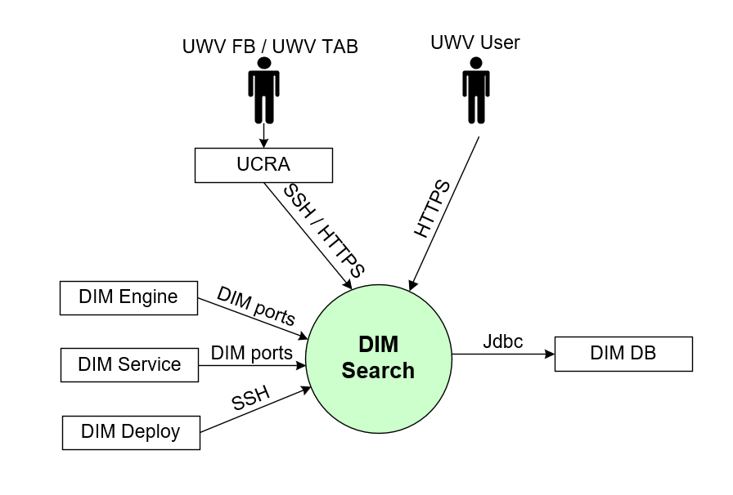

#### External entities

##### UWV FB / UWV TAB

|  |  |
| --- | --- |
| **Description** | A user performing functional and technical Application Management tasks. This is mainly related to the configuration of ETL processes and reports, but also management of the application itself. Web Browser and several IIS clients are used for performing these tasks. |
| **Protocol and Port** | SSH, port 22; HTTPS, port 443 |
| **DC (Datacenter) connection** | Internal (mandatory field) |
| **Direction** | Inbound (mandatory field) |
| **Direct connection** | No (mandatory field)  Via: UCRA |
| **Security Controls** | Authorisation method or authentication method: RBAC (AD) (KA AD group membership)  Use certificates: Yes (Entrust)  Service account: No |
| **Number of users** | 2-5 |
| **Number of transactions** | Not specified |
| **Frequency of transactions** | Daily |
| **Volume of data** | Not significant |

##### UWV User

|  |  |
| --- | --- |
| **Description** | A user interacting with the DIM-Infosphere Information Services, either by using the FAT client on the terminal server (UCRA) or directly access to the Webservices.  There are different kind of users:   1. PROD: access the data in the DIM-databases, and not the IIS-environment. 2. ACC: access the data in the DIM-databases, and not the IIS-environment. 3. DEV/TEST: No users, but there are developers and testers |
| **Protocol and Port** | HTTPS, port 443 (InfoSphere Client to IIS Services server) |
| **DC (Datacenter) connection** | External (mandatory field) |
| **Direction** | Inbound (mandatory field) |
| **Direct connection** | Yes (mandatory field)  Via: <If No is selected specifiy otherwise mention not applicable> |
| **Security Controls** | Authorisation method or authentication method: RBAC (AD) (mandatory)  Use certificates: Yes (Entrust)  Service account: No |
| **Number of users** | PROD: 100  ACC: 10  DEV/TEST: 30 |
| **Number of transactions** | Not specified |
| **Frequency of transactions** | Daily |
| **Volume of data** | Not significant |

##### DIM DB

|  |  |
| --- | --- |
| **Description** | Database connection to Infosphere DB |
| **Protocol and Port** | Jdbc, 1526 |
| **DC (Datacenter) connection** | Internal (mandatory field) |
| **Direction** | Outbound (mandatory field) |
| **Direct connection** | Yes (mandatory field)  Via: <If No is selected specifiy otherwise mention not applicable> |
| **Security Controls** | Authorisation method or authentication method: Select (mandatory)  Use certificates: No  Service account: No |
| **Number of users** | Not specified |
| **Number of transactions** | Not specified |
| **Frequency of transactions** | Not specified |
| **Volume of data** | Not specified |

##### DIM Deploy

|  |  |
| --- | --- |
| **Description** | Internal Application communication with the DIM Management server |
| **Protocol and Port** | SSH, 22 |
| **DC (Datacenter) connection** | Internal (mandatory field) |
| **Direction** | Inbound (mandatory field) |
| **Direct connection** | Yes (mandatory field)  Via: <If No is selected specifiy otherwise mention not applicable> |
| **Security Controls** | Authorisation method or authentication method: Select (local users)  Use certificates: No  Service account: No |
| **Number of users** | Not specified |
| **Number of transactions** | Not specified |
| **Frequency of transactions** | Not specified |
| **Volume of data** | Not specified |

##### DIM Service

|  |  |
| --- | --- |
| **Description** | Internal Application communication with DIM Services server |
| **Protocol and Port** | TCP: 2181, 9092 |
| **DC (Datacenter) connection** | Internal (mandatory field) |
| **Direction** | Inbound (mandatory field) |
| **Direct connection** | Yes (mandatory field)  Via: <If No is selected specifiy otherwise mention not applicable> |
| **Security Controls** | Authorisation method or authentication method: Select (not specified)  Use certificates: No  Service account: No |
| **Number of users** | Not specified |
| **Number of transactions** | Not specified |
| **Frequency of transactions** | Not specified |
| **Volume of data** | Not specified |

##### DIM Engine

|  |  |
| --- | --- |
| **Description** | Internal Application communication with DIM Engine |
| **Protocol and Port** | TCP: 9092 |
| **DC (Datacenter) connection** | Internal (mandatory field) |
| **Direction** | Inbound (mandatory field) |
| **Direct connection** | Yes (mandatory field)  Via: <If No is selected specifiy otherwise mention not applicable> |
| **Security Controls** | Authorisation method or authentication method: Select (not specified)  Use certificates: No  Service account: No |
| **Number of users** | Not specified |
| **Number of transactions** | Not specified |
| **Frequency of transactions** | Not specified |
| **Volume of data** | Not specified |

### DIM Engine

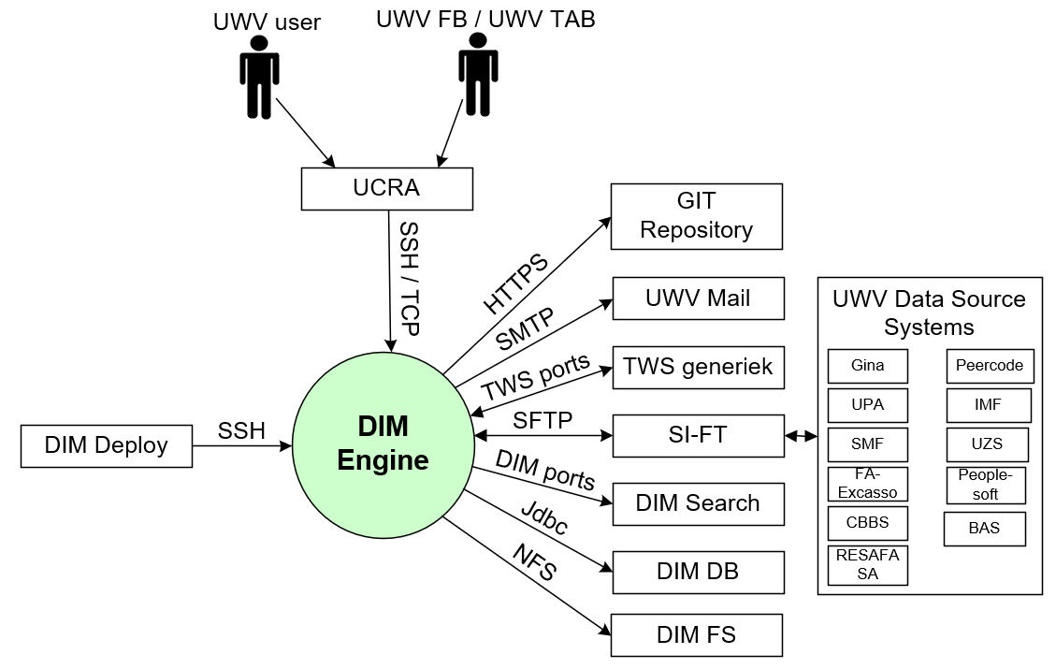

#### External entities

##### UWV FB / UWV TAB

|  |  |
| --- | --- |
| **Description** | A user performing functional and technical Application Management tasks. This is mainly related to the configuration of ETL processes and reports, but also management of the application itself. Web Browser and several IIS clients are used for performing these tasks. |
| **Protocol and Port** | SSH, port 22; TCP, port 31538 |
| **DC (Datacenter) connection** | Internal (mandatory field) |
| **Direction** | Inbound (mandatory field) |
| **Direct connection** | No (mandatory field)  Via: UCRA |
| **Security Controls** | Authorisation method or authentication method: RBAC (AD) (KA AD group membership)  Use certificates: Yes (Entrust)  Service account: No |
| **Number of users** | 2-5 |
| **Number of transactions** | Not specified |
| **Frequency of transactions** | Daily |
| **Volume of data** | Not significant |

##### UWV User

|  |  |
| --- | --- |
| **Description** | UWV users Developpers and Data Engineers as part of UWV Users community to connect only on O and T. |
| **Protocol and Port** | SSH, port 22; TCP, port 31538 |
| **DC (Datacenter) connection** | Internal (mandatory field) |
| **Direction** | Inbound (mandatory field) |
| **Direct connection** | No (mandatory field)  Via: UCRA |
| **Security Controls** | Authorisation method or authentication method: RBAC (AD) (KA AD group membership)  Use certificates: Yes (Entrust)  Service account: No |
| **Number of users** | Not specified |
| **Number of transactions** | Not specified |
| **Frequency of transactions** | Daily |
| **Volume of data** | Not significant |

##### GIT Repository

|  |  |
| --- | --- |
| **Description** | UWV GIT software version control and source code system in OToD. Used from Test and Development only. |
| **Protocol and Port** | HTTPS, port 443, 7070 |
| **DC (Datacenter) connection** | Internal (mandatory field) |
| **Direction** | Outbound (mandatory field) |
| **Direct connection** | Yes (mandatory field)  Via: <If No is selected specifiy otherwise mention not applicable> |
| **Security Controls** | Authorisation method or authentication method: Select (not specified)  Use certificates: No  Service account: No |
| **Number of users** | 2 |
| **Number of transactions** | Not specified |
| **Frequency of transactions** | Not specified |
| **Volume of data** | Not significant |

##### UWV Mail

|  |  |
| --- | --- |
| **Description** | UWV MailRelay service used by Datastage to send notification mails. |
| **Protocol and Port** | SMTP, port 25 (STARTTLS Option see 4.5.1) |
| **DC (Datacenter) connection** | External (mandatory field) |
| **Direction** | Outbound (mandatory field) |
| **Direct connection** | Yes (mandatory field)  Via: <If No is selected specifiy otherwise mention not applicable> |
| **Security Controls** | Authorisation method or authentication method: Select (server must be added to Mail ACL)  Use certificates: No  Service account: No |
| **Number of users** | 4 |
| **Number of transactions** | Not specified |
| **Frequency of transactions** | Not specified |
| **Volume of data** | Not significant |

##### TWS Generiek

|  |  |
| --- | --- |
| **Description** | Generic Workload Scheduler facility for UWV applications, communication over the default TWS ports |
| **Protocol and Port** | Connection 1: TCP, port 31111, 31116 (outbound)  Connection 2: TCP, port 34243 (inbound) |
| **DC (Datacenter) connection** | Connection 1: Internal (mandatory field)  Connection 2: Internal (mandatory field) |
| **Direction** | Connection 1: Outbound (mandatory field)  Connection 2: Inbound (mandatory field) |
| **Direct connection** | Connection 1: Yes (mandatory field)  Connection 2: Yes (mandatory field) |
| **Security Controls** | Authorisation method or authentication method: Select (not specified)  Use certificates: No  Service account: No |
| **Number of users** | 1 |
| **Number of transactions** | Not specified |
| **Frequency of transactions** | Not specified |
| **Volume of data** | Not significant |

##### SI-FT

|  |  |
| --- | --- |
| **Description** | Connection with SI-Filetransfer. SI-FT connects with UWV data source systems. It concerns systems with UWV business data from which the DIM fetches data for processing. This concerns only the file pattern.  Currently and during migration project SI-FT puts data only on the DIM Engine server. SI-FT is used for file and dump accesses.  The next data source systems will be accessed:  Gina, UPA, SMF, FA-Excasso, CBBS, Peercode, IMF, UZS, Peoplesoft, RESAFASA, BAS |
| **Protocol and Port** | SFTP, port 22 |
| **DC (Datacenter) connection** | Internal (mandatory field) |
| **Direction** | Inbound and Outbound (mandatory field) |
| **Direct connection** | Yes (mandatory field)  Via: <If No is selected specifiy otherwise mention not applicable> |
| **Security Controls** | Authorisation method or authentication method: Select (Database or domain account giving access to the data object)  Use certificates: No (mandatory)  Service account: No |
| **Number of users** | Not specified |
| **Number of transactions** | Not specified |
| **Frequency of transactions** | Daily |
| **Volume of data** | All UWV systems can become a source system for DIM. This sizing based on DIM having roughly the same source systems as the combination of the current DWH's DWARFS, UDS and NGP (32 in total). Total volume of input data: typically, 2 TB/day, peaks at 5 TB/day (worst case; assumes all data processed using ETL-pattern).  Existing sourcing currently divided in equal parts export/import, bespoke extracts, and database links. Considering that not all sources will be able to deliver their data via SI FT, sourcing will therefore be roughly evenly split between direct transport and SI FT.  Volume of data (direct connection): 1TB/day, peaking at 2,5 TB/day |

##### DIM Search

|  |  |
| --- | --- |
| **Description** | Internal Application communication with DIM search |
| **Protocol and Port** | TCP: 9092 |
| **DC (Datacenter) connection** | Internal (mandatory field) |
| **Direction** | Outbound (mandatory field) |
| **Direct connection** | Yes (mandatory field)  Via: <If No is selected specifiy otherwise mention not applicable> |
| **Security Controls** | Authorisation method or authentication method: Select (not specified)  Use certificates: No  Service account: No |
| **Number of users** | Not specified |
| **Number of transactions** | Not specified |
| **Frequency of transactions** | Not specified |
| **Volume of data** | Not specified |

##### DIM DB

|  |  |
| --- | --- |
| **Description** | Database connection to Infosphere DB |
| **Protocol and Port** | Jdbc, 1526 |
| **DC (Datacenter) connection** | Internal (mandatory field) |
| **Direction** | Outbound (mandatory field) |
| **Direct connection** | Yes (mandatory field)  Via: <If No is selected specifiy otherwise mention not applicable> |
| **Security Controls** | Authorisation method or authentication method: Select (not specified)  Use certificates: No  Service account: No |
| **Number of users** | Not specified |
| **Number of transactions** | Not specified |
| **Frequency of transactions** | Not specified |
| **Volume of data** | Not specified |

##### DIM FS

|  |  |
| --- | --- |
| **Description** | DIM-Infosphere NFS servers are setup to provide cold and hot storage for the engine and database servers. |
| **Protocol and Port** | NFS: 111, 635, 2049, 4045, 4046 |
| **DC (Datacenter) connection** | Internal (mandatory field) |
| **Direction** | Outbound (mandatory field) |
| **Direct connection** | Yes (mandatory field)  Via: <If No is selected specifiy otherwise mention not applicable> |
| **Security Controls** | Authorisation method or authentication method: Select (not specified)  Use certificates: No  Service account: No |
| **Number of users** | Not specified |
| **Number of transactions** | Not specified |
| **Frequency of transactions** | Not specified |
| **Volume of data** | Not specified |

##### DIM Deploy

|  |  |
| --- | --- |
| **Description** | Internal Application communication with the DIM Management server |
| **Protocol and Port** | SSH, 22 |
| **DC (Datacenter) connection** | Internal (mandatory field) |
| **Direction** | Inbound (mandatory field) |
| **Direct connection** | Yes (mandatory field)  Via: <If No is selected specifiy otherwise mention not applicable> |
| **Security Controls** | Authorisation method or authentication method: Select (local users)  Use certificates: No  Service account: No |
| **Number of users** | Not specified |
| **Number of transactions** | Not specified |
| **Frequency of transactions** | Not specified |
| **Volume of data** | Not specified |

### DIM Bridge

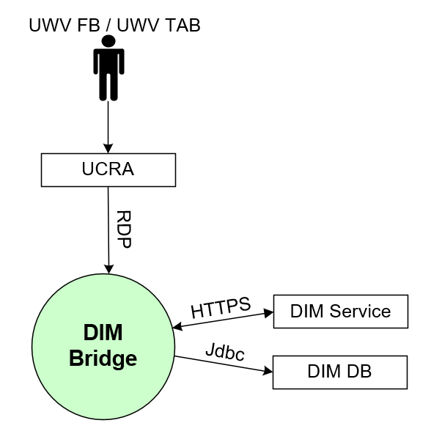

#### External entities

##### UWV FB / UWV TAB

|  |  |
| --- | --- |
| **Description** | A user performing functional and technical Application Management tasks. This is mainly related to the configuration of ETL processes and reports, but also management of the application itself. Web Browser and several IIS clients are used for performing these tasks. |
| **Protocol and Port** | RDP 3389 |
| **DC (Datacenter) connection** | Internal (mandatory field) |
| **Direction** | Inbound (mandatory field) |
| **Direct connection** | No (mandatory field)  Via: UCRA |
| **Security Controls** | Authorisation method or authentication method: RBAC (AD) (KA AD group membership)  Use certificates: Yes (Entrust)  Service account: No |
| **Number of users** | 2-5 |
| **Number of transactions** | Not specified |
| **Frequency of transactions** | Daily |
| **Volume of data** | Not significant |

##### DIM Service

|  |  |
| --- | --- |
| **Description** | Internal Application communication with DIM Bridge |
| **Protocol and Port** | Connection 1: HTTPS, 19433  Connection 2: HTTPS, 9433 |
| **DC (Datacenter) connection** | Connection 1: Internal (mandatory field)  Connection 2: Internal (mandatory field) |
| **Direction** | Connection 1: Inbound (mandatory field)  Connection 2: Outbound (mandatory field) |
| **Direct connection** | Connection 1: Yes (mandatory field)  Connection 2: Yes (mandatory field) |
| **Security Controls** | Authorisation method or authentication method: Select (not specified)  Use certificates: Yes (Entrust)  Service account: No |
| **Number of users** | Not specified |
| **Number of transactions** | Not specified |
| **Frequency of transactions** | Not specified |
| **Volume of data** | Not specified |

##### DIM DB

|  |  |
| --- | --- |
| **Description** | Database connection to Infosphere DB |
| **Protocol and Port** | Jdbc, 1526 |
| **DC (Datacenter) connection** | Internal (mandatory field) |
| **Direction** | Outbound (mandatory field) |
| **Direct connection** | Yes (mandatory field)  Via: <If No is selected specifiy otherwise mention not applicable> |
| **Security Controls** | Authorisation method or authentication method: Select (not specified)  Use certificates: No  Service account: No |
| **Number of users** | Not specified |
| **Number of transactions** | Not specified |
| **Frequency of transactions** | Not specified |
| **Volume of data** | Not specified |

### DIM DB

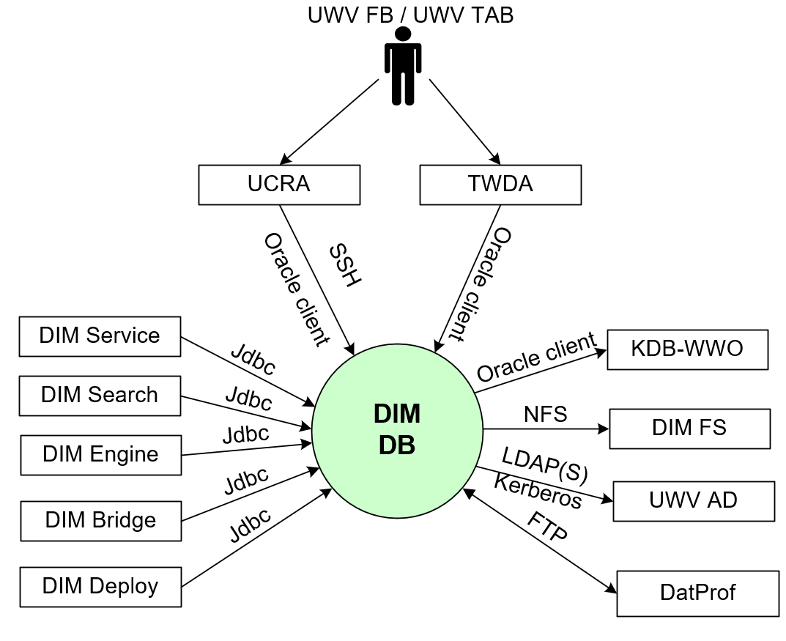

#### External entities

##### UWV FB / UWV TAB

|  |  |
| --- | --- |
| **Description** | A user performing functional and technical Application Management tasks. This is mainly related to the configuration of ETL processes and reports, but also management of the application itself. Web Browser and several IIS clients are used for performing these tasks. |
| **Protocol and Port** | SSH, port 22; Oracle client, port 1526 |
| **DC (Datacenter) connection** | Internal (mandatory field) |
| **Direction** | Inbound (mandatory field) |
| **Direct connection** | No (mandatory field)  Via: UCRA/TWDA |
| **Security Controls** | Authorisation method or authentication method: RBAC (AD) (KA AD group membership)  Use certificates: No  Service account: No |
| **Number of users** | 2-5 |
| **Number of transactions** | Not specified |
| **Frequency of transactions** | Daily |
| **Volume of data** | Not significant |

##### KDB-WWO

|  |  |
| --- | --- |
| **Description** | The KDB-WWO is a copy database from the WWO-database (DK instances and HK Instance) which is synchonized to realtime. Database schemas are equal to the schemas of WWO. |
| **Protocol and Port** | Oracle client, 1526 |
| **DC (Datacenter) connection** | Select (mandatory field) |
| **Direction** | Outbound (mandatory field) |
| **Direct connection** | Yes (mandatory field)  Via: <If No is selected specifiy otherwise mention not applicable> |
| **Security Controls** | Authorisation method or authentication method: Select (not specified)  Use certificates: No  Service account: No |
| **Number of users** | Not specified |
| **Number of transactions** | Not specified |
| **Frequency of transactions** | Not specified |
| **Volume of data** | Not specified |

##### DatProf

|  |  |
| --- | --- |
| **Description** | DatProf connection, used for anonymizing the database |
| **Protocol and Port** | FTP, 21 |
| **DC (Datacenter) connection** | Select (yes) |
| **Direction** | Inbound and Outbound (mandatory field) |
| **Direct connection** | Yes (mandatory field)  Via: <If No is selected specifiy otherwise mention not applicable> |
| **Security Controls** | Authorisation method or authentication method: Select (not specified)  Use certificates: No  Service account: No |
| **Number of users** | Not specified |
| **Number of transactions** | Not specified |
| **Frequency of transactions** | Not specified |
| **Volume of data** | Not specified |

##### DIM FS

|  |  |
| --- | --- |
| **Description** | DIM-Infosphere NFS servers are setup to provide cold and hot storage for the engine and database servers. |
| **Protocol and Port** | NFS: 111, 635, 2049, 4045, 4046 |
| **DC (Datacenter) connection** | Internal (mandatory field) |
| **Direction** | Outbound (mandatory field) |
| **Direct connection** | Yes (mandatory field)  Via: <If No is selected specifiy otherwise mention not applicable> |
| **Security Controls** | Authorisation method or authentication method: Select (not specified)  Use certificates: No  Service account: No |
| **Number of users** | Not specified |
| **Number of transactions** | Not specified |
| **Frequency of transactions** | Not specified |
| **Volume of data** | Not specified |

##### UWV AD

|  |  |
| --- | --- |
| **Description** | Windows Active Directory domain containing resource groups of which UWV domain (KA prod or WPOL) user groups are member, and by which UWV accounts are granted rights.  Kerberos implementation required to use Global groups |
| **Protocol and Port** | Kerberos (88), LDAP (389), LDAPS (636) |
| **DC (Datacenter) connection** | External (mandatory field) |
| **Direction** | Outbound (mandatory field) |
| **Direct connection** | Yes (mandatory field)  Via: <If No is selected specifiy otherwise mention not applicable> |
| **Security Controls** | Authorisation method or authentication method: RBAC (AD) (mandatory)  Use certificates: No  Service account: Yes |
| **Number of users** | Not specified |
| **Number of transactions** | Not specified |
| **Frequency of transactions** | Not specified |
| **Volume of data** | Not specified |

##### DIM Bridge

|  |  |
| --- | --- |
| **Description** | Database connection to Infosphere DB |
| **Protocol and Port** | Jdbc, 1526 |
| **DC (Datacenter) connection** | Internal (mandatory field) |
| **Direction** | Inbound (mandatory field) |
| **Direct connection** | Yes (mandatory field)  Via: <If No is selected specifiy otherwise mention not applicable> |
| **Security Controls** | Authorisation method or authentication method: Select (not specified)  Use certificates: No  Service account: No |
| **Number of users** | Not specified |
| **Number of transactions** | Not specified |
| **Frequency of transactions** | Not specified |
| **Volume of data** | Not specified |

##### DIM Engine

|  |  |
| --- | --- |
| **Description** | Database connection to Infosphere DB |
| **Protocol and Port** | Jdbc, 1526 |
| **DC (Datacenter) connection** | Internal (mandatory field) |
| **Direction** | Inbound (mandatory field) |
| **Direct connection** | Yes (mandatory field)  Via: <If No is selected specifiy otherwise mention not applicable> |
| **Security Controls** | Authorisation method or authentication method: Select (not specified)  Use certificates: No  Service account: No |
| **Number of users** | Not specified |
| **Number of transactions** | Not specified |
| **Frequency of transactions** | Not specified |
| **Volume of data** | Not specified |

##### DIM Search

|  |  |
| --- | --- |
| **Description** | Database connection to Infosphere DB |
| **Protocol and Port** | Jdbc, 1526 |
| **DC (Datacenter) connection** | Internal (mandatory field) |
| **Direction** | Inbound (mandatory field) |
| **Direct connection** | Yes (mandatory field)  Via: <If No is selected specifiy otherwise mention not applicable> |
| **Security Controls** | Authorisation method or authentication method: Select (not specified)  Use certificates: No  Service account: No |
| **Number of users** | Not specified |
| **Number of transactions** | Not specified |
| **Frequency of transactions** | Not specified |
| **Volume of data** | Not specified |

##### DIM Service

|  |  |
| --- | --- |
| **Description** | Database connection to Infosphere DB |
| **Protocol and Port** | Jdbc, 1526 |
| **DC (Datacenter) connection** | Internal (mandatory field) |
| **Direction** | Inbound (mandatory field) |
| **Direct connection** | Yes (mandatory field)  Via: <If No is selected specifiy otherwise mention not applicable> |
| **Security Controls** | Authorisation method or authentication method: Select (not specified)  Use certificates: No  Service account: No |
| **Number of users** | Not specified |
| **Number of transactions** | Not specified |
| **Frequency of transactions** | Not specified |
| **Volume of data** | Not specified |

##### DIM Deploy

|  |  |
| --- | --- |
| **Description** | Internal Application communication with the DIM Management server |
| **Protocol and Port** | Oracle client, 1526 |
| **DC (Datacenter) connection** | Internal (mandatory field) |
| **Direction** | Inbound (mandatory field) |
| **Direct connection** | Yes (mandatory field)  Via: <If No is selected specifiy otherwise mention not applicable> |
| **Security Controls** | Authorisation method or authentication method: Select (local users)  Use certificates: No  Service account: No |
| **Number of users** | Not specified |
| **Number of transactions** | Not specified |
| **Frequency of transactions** | Not specified |
| **Volume of data** | Not specified |

##### DIM Deploy

|  |  |
| --- | --- |
| **Description** | Internal Application communication with the DIM Management server |
| **Protocol and Port** | Oracle Enterprise Manager, 3872 |
| **DC (Datacenter) connection** | Internal (mandatory field) |
| **Direction** | Inbound (mandatory field) |
| **Direct connection** | Yes (mandatory field) |
| **Security Controls** | Authorisation method or authentication method: Select (local users)  Use certificates: No  Service account: No |
| **Number of users** | Not specified |
| **Number of transactions** | Not specified |
| **Frequency of transactions** | Not specified |
| **Volume of data** | Not specified |

##### DIM Deploy

|  |  |
| --- | --- |
| **Description** | Internal Application communication with the DIM Management server |
| **Protocol and Port** | Oracle Enterprise manager Agent, 1159 and 4889 |
| **DC (Datacenter) connection** | Internal (mandatory field) |
| **Direction** | Outbound (mandatory field) |
| **Direct connection** | Yes (mandatory field) |
| **Security Controls** | Authorisation method or authentication method: Select (local users)  Use certificates: No  Service account: No |
| **Number of users** | Not specified |
| **Number of transactions** | Not specified |
| **Frequency of transactions** | Not specified |
| **Volume of data** | Not specified |

### DIM FS

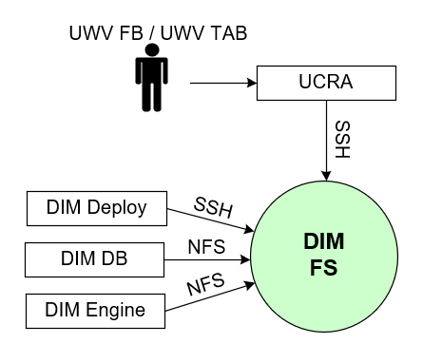

#### External entities

##### UWV FB / UWV TAB

|  |  |
| --- | --- |
| **Description** | A user performing functional and technical Application Management tasks. This is mainly related to the configuration of ETL processes and reports, but also management of the application itself. Web Browser and several IIS clients are used for performing these tasks. |
| **Protocol and Port** | SSH, port 22 |
| **DC (Datacenter) connection** | Internal (mandatory field) |
| **Direction** | Inbound (mandatory field) |
| **Direct connection** | No (mandatory field)  Via: UCRA |
| **Security Controls** | Authorisation method or authentication method: RBAC (AD) (KA AD group membership)  Use certificates: No  Service account: No |
| **Number of users** | 2-5 |
| **Number of transactions** | Not specified |
| **Frequency of transactions** | Daily |
| **Volume of data** | Not significant |

##### DIM Engine

|  |  |
| --- | --- |
| **Description** | DIM FS (NFS server connection) connection to cold and hot storage |
| **Protocol and Port** | NFS: 111, 635, 2049, 4045, 4046 |
| **DC (Datacenter) connection** | Internal (mandatory field) |
| **Direction** | Inbound (mandatory field) |
| **Direct connection** | Yes (mandatory field)  Via: <If No is selected specifiy otherwise mention not applicable> |
| **Security Controls** | Authorisation method or authentication method: Select (not specfied)  Use certificates: No  Service account: No |
| **Number of users** | Not specified |
| **Number of transactions** | Not specified |
| **Frequency of transactions** | Not specified |
| **Volume of data** | Not specified |

##### DIM DB

|  |  |
| --- | --- |
| **Description** | DIM FS (NFS server connection) connection to cold and hot storage |
| **Protocol and Port** | NFS: 111, 635, 2049, 4045, 4046 |
| **DC (Datacenter) connection** | Internal (mandatory field) |
| **Direction** | Inbound (mandatory field) |
| **Direct connection** | Yes (mandatory field)  Via: <If No is selected specifiy otherwise mention not applicable> |
| **Security Controls** | Authorisation method or authentication method: Select (not specfied)  Use certificates: No  Service account: No |
| **Number of users** | Not specified |
| **Number of transactions** | Not specified |
| **Frequency of transactions** | Not specified |
| **Volume of data** | Not specified |

##### DIM Deploy

|  |  |
| --- | --- |
| **Description** | Internal Application communication with the DIM Management server |
| **Protocol and Port** | SSH, 22 |
| **DC (Datacenter) connection** | Internal (mandatory field) |
| **Direction** | Inbound (mandatory field) |
| **Direct connection** | Yes (mandatory field)  Via: <If No is selected specifiy otherwise mention not applicable> |
| **Security Controls** | Authorisation method or authentication method: Select (local users)  Use certificates: No  Service account: No |
| **Number of users** | Not specified |
| **Number of transactions** | Not specified |
| **Frequency of transactions** | Not specified |
| **Volume of data** | Not specified |

### DIM Deploy

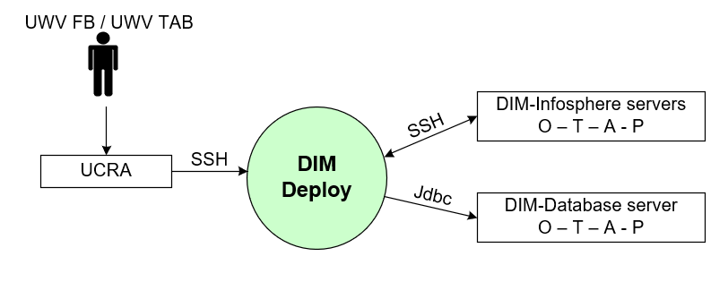

#### External entities

##### UWV FB / UWV TAB

|  |  |
| --- | --- |
| **Description** | A user performing functional and technical Application Management tasks. This is mainly related to the configuration of ETL processes and reports, but also management of the application itself. Web Browser and several IIS clients are used for performing these tasks. |
| **Protocol and Port** | SSH, port 22 |
| **DC (Datacenter) connection** | Internal (mandatory field) |
| **Direction** | Inbound (mandatory field) |
| **Direct connection** | No (mandatory field)  Via: UCRA |
| **Security Controls** | Authorisation method or authentication method: RBAC (AD) (KA AD group membership)  Use certificates: No  Service account: No |
| **Number of users** | 2-5 |
| **Number of transactions** | Not specified |
| **Frequency of transactions** | Daily |
| **Volume of data** | Not significant |

##### DIM-Infosphere servers O – T – A - P

|  |  |
| --- | --- |
| **Description** | UWV FB provides promotions of new versions from DEVELOPMENT to TEST, ACCEPTANCE and PRODUCTION  This is the connection to all DIM Infosphere servers in the Deployment, Test, Acceptance and Production environment |
| **Protocol and Port** | SSH, port 22 |
| **DC (Datacenter) connection** | Internal (mandatory field) |
| **Direction** | Inbound and Outbound |
| **Direct connection** | Yes (mandatory field)  Via: <If No is selected specifiy otherwise mention not applicable> |
| **Security Controls** | Authorisation method or authentication method: Select (not specified)  Use certificates: No  Service account: No |
| **Number of users** | 2 |
| **Number of transactions** | Not specified |
| **Frequency of transactions** | Not specified |
| **Volume of data** | Not significant |

##### DIM-database server O -T -A - P

|  |  |
| --- | --- |
| **Description** | UWV FB provides promotions of new versions from DEVELOPMENT to TEST, ACCEPTANCE and PRODUCTION  This is the connection to all DIM database servers in the Deployment, Test, Acceptance and Production environment |
| **Protocol and Port** | Oracle Client, port 1526 |
| **DC (Datacenter) connection** | Internal (mandatory field) |
| **Direction** | Outbound |
| **Direct connection** | Yes (mandatory field)  Via: <If No is selected specifiy otherwise mention not applicable> |
| **Security Controls** | Authorisation method or authentication method: Select (not specified)  Use certificates: No  Service account: No |
| **Number of users** | 2 |
| **Number of transactions** | Not specified |
| **Frequency of transactions** | Not specified |
| **Volume of data** | Not significant |

##### DIM-database server O -T -A - P

|  |  |
| --- | --- |
| **Description** | Oracle Enterprise Manager connects to all databases for management and monitoring tasks.  This is the connection to all DIM database servers in the Deployment, Test, Acceptance and Production environment |
| **Protocol and Port** | Oracle Enterprise Manager, port 3872 |
| **DC (Datacenter) connection** | Internal (mandatory field) |
| **Direction** | Outbound |
| **Direct connection** | Yes (mandatory field)  Via: <If No is selected specifiy otherwise mention not applicable> |
| **Security Controls** | Authorisation method or authentication method: Select (not specified)  Use certificates: No  Service account: No |
| **Number of users** | N/A |
| **Number of transactions** | Not specified |
| **Frequency of transactions** | Not specified |
| **Volume of data** | Not significant |

##### DIM-database server O -T -A - P

|  |  |
| --- | --- |
| **Description** | Oracle Enterprise Manager incoming traffic from OEM Agents.  This is the connection from all DIM database servers in the Deployment, Test, Acceptance and Production environment |
| **Protocol and Port** | Oracle Enterprise Manager Agent, port 1159 and 4889 |
| **DC (Datacenter) connection** | Internal (mandatory field) |
| **Direction** | Inbound |
| **Direct connection** | Yes (mandatory field)  Via: <If No is selected specifiy otherwise mention not applicable> |
| **Security Controls** | Authorisation method or authentication method: Select (not specified)  Use certificates: No  Service account: No |
| **Number of users** | N/A |
| **Number of transactions** | Not specified |
| **Frequency of transactions** | Not specified |
| **Volume of data** | Not significant |

##### DBA-GD RDP

|  |  |
| --- | --- |
| **Description** | Access to the Oracle Enterprise Manager Management Interface  This is the connection from DBA-GD RDP to DIM Management server |
| **Protocol and Port** | Oracle Enterprise Manager HTTP(S), port 7799 and 7788 |
| **DC (Datacenter) connection** | Internal (mandatory field) |
| **Direction** | Inbound |
| **Direct connection** | Yes (mandatory field)  Via: <If No is selected specifiy otherwise mention not applicable> |
| **Security Controls** | Authorisation method or authentication method: Select (not specified)  Use certificates: No  Service account: No |
| **Number of users** | 3 |
| **Number of transactions** | Not specified |
| **Frequency of transactions** | Not specified |
| **Volume of data** | Not significant |

##### DBA-GD RDP

|  |  |
| --- | --- |
| **Description** | Oracle DB client inbound for managing OEM Repository Database  This is the connection to DIM Management server from DBA-GD RDP |
| **Protocol and Port** | Oracle Client, port 1526 |
| **DC (Datacenter) connection** | Internal (mandatory field) |
| **Direction** | Inbound |
| **Direct connection** | Yes (mandatory field)  Via: <If No is selected specifiy otherwise mention not applicable> |
| **Security Controls** | Authorisation method or authentication method: Select (not specified)  Use certificates: No  Service account: No |
| **Number of users** | 3 |
| **Number of transactions** | Not specified |
| **Frequency of transactions** | Not specified |
| **Volume of data** | Not significant |

### DBA-GD RDP



#### External entities

##### UWV FB / UWV TAB

|  |  |
| --- | --- |
| **Description** | DBA Gegegevensdiensten who need to be able to manage the database of DIM Infosphere and DWH |
| **Protocol and Port** | RDP, port 3389 |
| **DC (Datacenter) connection** | External (mandatory field) |
| **Direction** | Inbound (mandatory field) |
| **Direct connection** | Yes (mandatory field)  Via: <If No is selected specifiy otherwise mention not applicable> |
| **Security Controls** | Authorisation method or authentication method: RBAC (AD) (KA AD group membership)  Use certificates: No  Service account: No |
| **Number of users** | 5 concurrent users |
| **Number of transactions** | Not specified |
| **Frequency of transactions** | Daily |
| **Volume of data** | Not significant |

##### DIM-Infosphere Windows O – T – A - P

|  |  |
| --- | --- |
| **Description** | UWV FB provides promotions of new versions from DEVELOPMENT to TEST, ACCEPTANCE and PRODUCTION  This is the connection to all DIM Infosphere Windows servers in the Deployment, Test, Acceptance and Production environment |
| **Protocol and Port** | RDP, port 3389 |
| **DC (Datacenter) connection** | Internal (mandatory field) |
| **Direction** | Outbound |
| **Direct connection** | Yes |
| **Security Controls** | Authorisation method or authentication method: Select (not specified)  Use certificates: No  Service account: No |
| **Number of users** | 2 |
| **Number of transactions** | Not specified |
| **Frequency of transactions** | Not specified |
| **Volume of data** | Not significant |

##### DIM-Infosphere Linux O – T – A - P

|  |  |
| --- | --- |
| **Description** | UWV FB provides promotions of new versions from DEVELOPMENT to TEST, ACCEPTANCE and PRODUCTION  This is the connection to all DIM Infosphere Linux servers in the Deployment, Test, Acceptance and Production environment |
| **Protocol and Port** | SSH, port 22 |
| **DC (Datacenter) connection** | Internal (mandatory field) |
| **Direction** | Outbound |
| **Direct connection** | Yes (mandatory field)  Via: <If No is selected specifiy otherwise mention not applicable> |
| **Security Controls** | Authorisation method or authentication method: Select (not specified)  Use certificates: No  Service account: No |
| **Number of users** | 2 |
| **Number of transactions** | Not specified |
| **Frequency of transactions** | Not specified |
| **Volume of data** | Not significant |

##### DWH database server O -T -A - P

|  |  |
| --- | --- |
| **Description** | UWV FB provides promotions of new versions from DEVELOPMENT to TEST, ACCEPTANCE and PRODUCTION  This is the connection to all DIM database servers in the Deployment, Test, Acceptance and Production environment |
| **Protocol and Port** | SSH (22), FTP (21) |
| **DC (Datacenter) connection** | Internal (mandatory field) |
| **Direction** | Outbound |
| **Direct connection** | Yes (mandatory field)  Via: <If No is selected specifiy otherwise mention not applicable> |
| **Security Controls** | Authorisation method or authentication method: Select (not specified)  Use certificates: No  Service account: No |
| **Number of users** | 2 |
| **Number of transactions** | Not specified |
| **Frequency of transactions** | Not specified |
| **Volume of data** | Not significant |

##### DIM-database server O -T -A - P

|  |  |
| --- | --- |
| **Description** | UWV FB provides promotions of new versions from DEVELOPMENT to TEST, ACCEPTANCE and PRODUCTION  This is the connection to all DIM database servers in the Deployment, Test, Acceptance and Production environment |
| **Protocol and Port** | Oracle Client, port 1526 |
| **DC (Datacenter) connection** | Internal (mandatory field) |
| **Direction** | Outbound |
| **Direct connection** | Yes (mandatory field)  Via: <If No is selected specifiy otherwise mention not applicable> |
| **Security Controls** | Authorisation method or authentication method: Select (not specified)  Use certificates: No  Service account: No |
| **Number of users** | 2 |
| **Number of transactions** | Not specified |
| **Frequency of transactions** | Not specified |
| **Volume of data** | Not significant |

##### DIM-Management server - OEM Webinterface

|  |  |
| --- | --- |
| **Description** | Access to the Oracle Enterprise Manager Management Interface  This is the connection from DBA-GD RDP to DIM Management server |
| **Protocol and Port** | Oracle Enterprise Manager HTTP(S), port 7799 and 7788 |
| **DC (Datacenter) connection** | Internal (mandatory field) |
| **Direction** | Outbound |
| **Direct connection** | Yes (mandatory field)  Via: <If No is selected specifiy otherwise mention not applicable> |
| **Security Controls** | Authorisation method or authentication method: Select (not specified)  Use certificates: No  Service account: No |
| **Number of users** | 3 |
| **Number of transactions** | Not specified |
| **Frequency of transactions** | Not specified |
| **Volume of data** | Not significant |

##### DIM-Management server – Oracle DB Client

|  |  |
| --- | --- |
| **Description** | Access oracle client for management of OEM Repository database  This is the connection from DBA-GD RDP to DIM Management server |
| **Protocol and Port** | Oracle Client, port 1526 |
| **DC (Datacenter) connection** | Internal (mandatory field) |
| **Direction** | Outbound |
| **Direct connection** | Yes (mandatory field)  Via: <If No is selected specifiy otherwise mention not applicable> |
| **Security Controls** | Authorisation method or authentication method: Select (not specified)  Use certificates: No  Service account: No |
| **Number of users** | 3 |
| **Number of transactions** | Not specified |
| **Frequency of transactions** | Not specified |
| **Volume of data** | Not significant |

# Functional Requirements

* UWV FB must be able to perform cross environment deployments (DEV to TEST to ACC to PROD promotion flexibility)
* The Acceptance environment must be equally sized (CPU and RAM) as the Production environment and setup in another data center.

# Non-Functional Requirements

## Security & Compliance classifications

For the BIV Rating the following repository is used: “2022 UWV-brede Risico Applicatie Lijst v1.0”

|  |  |
| --- | --- |
| **Application** | DIM-Infosphere |
| **Owner** | Gegevensdiensten |
| **Availability (Beschikbaarheid)** | 2(Hoog) |
| **Integrity (Integriteit)** | 2(hoog) |
| **Confidentiality (Vertrouwelijkheid)** | 3(Strikt vertrouwelijk) |
| **Type of information /Data Classification** | Personal information |

### Applicable security and compliance frameworks

|  |  |  |
| --- | --- | --- |
| Security & Compliance Framework | Applicable | Comments |
| BIO | Yes (applicable) | If Not Applicable (Not compliant) please explain |
| AVG / GDPR | Yes (applicable) | Only select No if no personal data is handled. GPDR is mandatory in all other cases |
| DIGID | No (not applicable) |  |
| SUWI | No |  |
| Additional frameworks | Not applicable |  |

## System and Software requirements

### Private Cloud system

#### System (Operating system (OS))

| **Server(type)** | **Operating System** | **Version** |
| --- | --- | --- |
| DIM Service | RHEL | 7.9 |
| DIM Search | RHEL | 7.9 |
| DIM Engine | RHEL | 7.9 |
| DIM Bridge | Windows | 2019 |
| DIM DB | AIX | 7.2 |
| DIM FS | RHEL | 7.9 |
| DIM Deploy | AIX | 7.2 |
|  |  |  |

#### System capacity forecast (volumetrics)

| **Server(type)** | **vCPU** | **RAM (GB)** | **Data Storage (GB)**  Data storage size for the OS is fixed |
| --- | --- | --- | --- |
| Client Tier |  |  | Existing UCRA servers will be used to deploy the DIM clients.  UCRA sizing will be managed by UCRA functional management. |
| Services Tier | 8 | 32 | 200 |
| Engine Tier | 8 | 64 | 1000 Scratch Disk  500 Persistent Storage  500 Shared GRID disk (only first node) |
| Fileserver Tier |  |  | 2000 Shared disk with DB Tier and data providers (HOT)  10000 Initial 10TB “Archive” growing to potentially 40TB in 5 years. Separate filesystem. (COLD) |
| Database Tier |  |  | *A new AIX database server under the CI of DIM-InfoSphere. This server contains only the DIM-Databases.* 2 TB minimum, depending on datafabriek source additions growth in 2 years to 20 TB |
| Metadata bridge Tier | 4 | 16 | 100 |
| Enterprise search Tier | 8 | 32 | 500 |
| Initial required capacity (estimated) for 2 non-P environments O + T: |  |  |  |
| Server(type) | vCPU | RAM (GB) | Data Storage (GB)  Data storage size for the OS is fixed |
| Client Tier |  |  | Existing UCRA servers will be used to deploy the DIM clients.  UCRA sizing will be managed by UCRA functional management. |
| Services Tier | 8 | 32 | 200 |
| Engine Tier | 8 | 32 | 200 Scratch Disk  500 Persistent Storage  500 Shared GRID disk (only first node) |
| Fileserver Tier |  |  | 2000 Shared disk with DB Tier and data providers (HOT)  4000 Separate filesystem. (COLD) technical equivalent to P+A. |
| Database Tier |  |  | A new AIX database server under the CI of DIM-InfoSphere. This server contains only the DIM-Databases. 2 TB minimum, depending on datafabriek source additions growth in 2 years to 20 TB |
| Metadata bridge Tier | 4 | 16 | 100 |
| Enterprise search Tier | 8 | 32 | 500 |

* All delivered source data must be processed within a 21:00 - 07:00 batch window.
* The OS version for the Services-, Engine- and Enterprise search Tier must be RedHat Enterprise Linux 7
* Shared GRID disk is required for application scalability (see also chapter 4.8)
* A Management server (OS = AIX) is needed for promotions between O-T-A-P
* IBM Infosphere implementation is based on 70 PVU’s (Processor Value Unit) per core, the processors in the DXC infrastructure must be compliant. For compliant processors see:

<https://www.ibm.com/software/passportadvantage/pvu_licensing_for_customers.html>

#### Availability

|  |  |  |
| --- | --- | --- |
| **Environment** | **DXC Application Target**  (Availability (service hours) = SLA) | **Infra Target* (only for Application target 98%)**  (Availability (service hours) = SLA) |
| Production | 98% (5 x12 (Mo-Fr, 7-19h)) = TAB Basis | 98% (7x24) = Bronze |
| Acceptance | 98% (5 x12 (Mo-Fr, 7-19h)) = TAB Basis | 98% (7x24) = Bronze |
| Test | 98% (5 x12 (Mo-Fr, 7-19h)) = TAB Basis | 98% (7x24) = Bronze |
| Development | 98% (5 x12 (Mo-Fr, 7-19h)) = TAB Basis | 98% (7x24) = Bronze |

#### Storage replication

|  |  |
| --- | --- |
| **Environment** | **Storage Replication** |
| Production | Replicated storage |
| Acceptance | Non-replicated storage |
| Test | Non-replicated storage |
| Development | Non-replicated storage |

#### Scalability

* The Engine Tier Must be able to scale horizontally and vertically. Horizontal scalability is provided by the application therefore the Engine Tier will be setup in an IBM Infosphere Data Stage GRID configuration.
* The Services Tier must be vertically scalable, it is setup on a single server as horizontal growth at this Tier is not expected in near future.
* The server topology of all environments (OTAP) needs to be the same.

| **Server(type)** | **Scalability type** | **Additional Comments** |
| --- | --- | --- |
| <example: server 1> | Kies een item. |  |
| <example: server 2> | Kies een item. |  |

#### Software (Licenses)

| **Server(type)** | **Software product / component** | **Version** |
| --- | --- | --- |
|  | Oracle Database server | 19.3 |
|  | Oracle advanced compression (Option) | 19.3 |
|  | Oracle Partitioning (Option) | 19.3 |
|  | Oracle Tuning Pack | 19.3 |
|  | Oracle Diagnostics Pack | 19.3 |
|  | WebSphere Application Server | 9.0 |
|  | WebSphere Application Server Network Deployment | 9.0.0.9 |
|  | IBM Tivoli Workload scheduler |  |
|  | IBM InfoSphere application components |  |
|  | Business Automation Workflow Enterprise | 19.0 |
|  | InfoSphere Data Architect | 9.1 |
|  | InfoSphere DataStage | 11.7 |
|  | InfoSphere DataStage and QualityStage Designer | 11.7 |
|  | InfoSphere FastTrack | 11.7 |
|  | InfoSphere Information Analyzer | 11.7 |
|  | InfoSphere Information Analyzer Workbench | 11.7 |
|  | InfoSphere Information Governance Catalog | 11.7 |
|  | InfoSphere Information Server | 11.7 |
|  | InfoSphere Information Services Director | 11.7 |
|  | InfoSphere QualityStage | 11.7 |
|  | Process Designer | 8.5 |
|  | RDS License (for DBA-GD-RDP) | 2019 |
|  |  |  |

Note: This HLD is based on the use of Production licences for both P and A, as the licensed amount of Production licenses is sufficient for both. Should a scale up or out be required in the future, then Production licenses need to be moved from A to P to allow for the P scale up/out, and additional non-Production licenses need to be purchased (by UWV) to allow for the scale up/out of A, and compensate for the production licences moved to P

There is a maximum amount of PVUs (Processor Value Units) licensed (only the Engine- and Services Tier are relevant for PVU counting):

Production:         1540 PVU

Non-Production: 1120 PVU

#### System management

If there are no specific system management, then state: “not applicable”

#### Additional application related infra requirements

|  |  |
| --- | --- |
| **Requirements** | **Status** |
| Use STARTTLS option for UWV mail1 | Yes |
| Is Microsoft DTC used for inflight transactions2 | Not applicable |
| Mention other relevant requirements |  |

Please note:

1 UWV mail (The internal KPN mailrelay's for UWV (uwvmailrelay.voorzieningen.uwv.nl, prt 25) is equipped with the STARTTLS option.

This means that every application server can now send the SMTP messages encrypted if desired. STARTTLS is based on negotiation. TLS is not mandatory but is preferred. Mail clients that do not want or cannot use TLS can continue to send mail.  The TLS version used is TLS V1.2. To enable TLS, systems must be provided with Digicert's root and intermediate certificates. This is a public CA that appears in all common certificate stores.

2 In case SQL AOAG (Always On Availability Groups) is used, then MSDTC (Microsoft Distribuited Transaction Coordinator) needs to be configured as a cluster service)

#### DXC TAB requirements

|  |  |
| --- | --- |
| **Category** | **Description** |
| 1. Deployment method | manual deployment |
| 1. Deployment permissions |  |
| 1. Application Monitoring |  |
| 1. Other TAB applicable requirement |  |

### Container application (MCPaaS)

NA

## Performance requirements

NA

## Security requirements

* UWV FB / UWV TAB requires RDP and SSH access to all DWH environments. Special rights are required. (This does **not apply** to the UCRA environment).
* SSH access to Linux/AIX servers require users in the DXC AD.
* RDP access to DIM Bridge server is required.
* OS permissions are required for: UWV FB, Tester, Developer.
* UWV FB must be able to perform:
  + Updates and upgrades, bring services down for (OS) maintenance support.
  + Cleaning
  + Authorizations on group level
  + Monitoring and performance analyses
  + Deployments.
  + Full rights on Oinstall group on DB server.
* DIM must be connected to the UWV AD directly for end user authentication and authorization within the application environment.
* IIS software is identically designed in all OTAP environments. This requires authorization based on ABS groups, so users can only do what they are authorized to do.
* On the IBM InfoSphere MicroServices Tier a UWV signed certificate is used to run kubectl via console
* The Docker and Kubernetes technologies provide the foundation for running microservices (search servers). Networking has a crucial role in this architecture. Kubernetes manages an internal Software Defined Network (the cluster network) and an internal name resolution system (DNS).

### System logging retention time

Standard

## Backup and Recovery

|  |  |  |
| --- | --- | --- |
|  | **Default** | **Deviation (when applicable)** |
| Backup | deviating backup | Backup exclusion: scratch and the grid disk on the engine server  Database: Archive log backup -> every 30 minutes |
| Restore | no specific restore order |  |
| Dependency | no dependencies |  |

## Disaster Recovery

No specific disaster recovery requirements applicable.

# Appendix: Legenda Context Diagram

